An efficient algorithm for finding a maximum weight 2-independent set on interval graphs.
Ju Yuan Hsiao and Chuan Yi Tang
Information Processing Letters, Vol.43, pp. 229-235
1.Introduction
definition :
MKIS: An independent set of a set of intervals I is a subset of the intervals 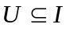 such that no two of the intervals in U overlap. The maximum k-independent set (MKIS) problem on I is to determine k disjoint sets 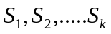 in I such that 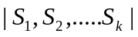 is maximum. The maximum 2-independent set (M21S) problem, which is a special case of the MKIS problem.
MWKIS: we associate to each interval in I a positive weight wt() and generalize the M21S problem as follows: Given a weighted interval set I, that is, each interval in I has a positive weight wt(), the maximum weight 2-independent set (MW21S) problem on I is to find a 2-independent set Q of I such that its weight wt(Q)= 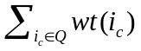 is maximum.
2. A linear time maximum weight independeri
algorithm
definition:
For each independent set S of I, define r(S) to be the largest index of the intervals in S. Define 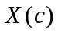 to be a set of independent sets of I with the constraint that for each independent set 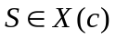, r(S) = c. Denote MWS(c) as an MWIS in X(c) and 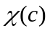 as the weight of MWS(c), that is, =wt(MWS(c)). Let l= 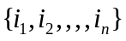 be a set of weighted intervals and 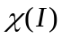 be the weight of an MWIS of I. Then, it is a clear that =max{| 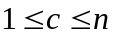}.
Theorem 2.1 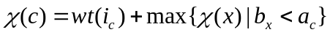for any
Algorithm:
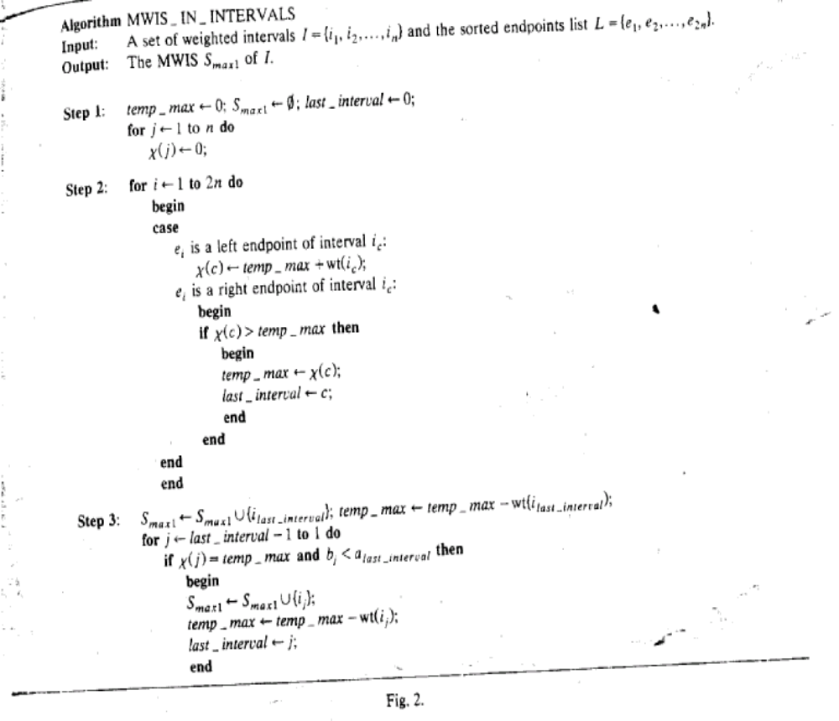Theorem2.2 The maximum weight independent set problem on interval graphs can be solved by algorithm MWIS_IN_INTERVALS in linear time if the sorted endpoints list is given.
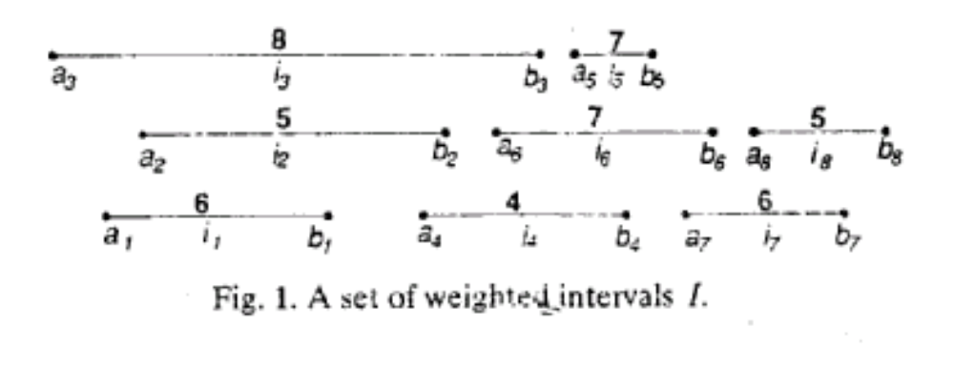
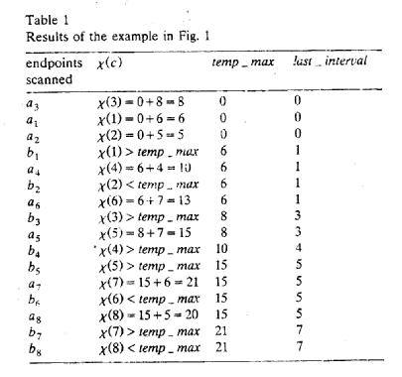
3.A maximum weight 2-independent set algorithm
definition: for any 2-independent set Q of I, it should be composed of two disjoint independent sets 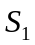 and 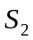 such that Q = 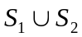 and 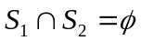.Define d(Q) = (r(), r()) and Y(k, j) to be a set of 2-independent sets of I with the constraint that for any Q Y(k, j), d(Q) =-(k, j), kj. Let MWQ(k,j) denote an MW2IS in Y(k, j) and u(k, j) denote the weight of MWQ(k, j) that is, wt(MWQ(k, j)) = u(k, j).
Lemma 3.1 Y(k, j)=Y(j, k) and u(k, j)=u(j,k) for any 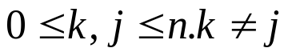
Lemma 3.2 Y(0,j)=X(j) and u(0,j)= 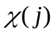, j=1,….n
Theorem 3.3 IF j>k,
u(k,j)= wt()+max{{u(k,x)| 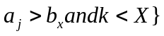 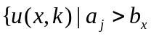 and x<k}}
algorithm:
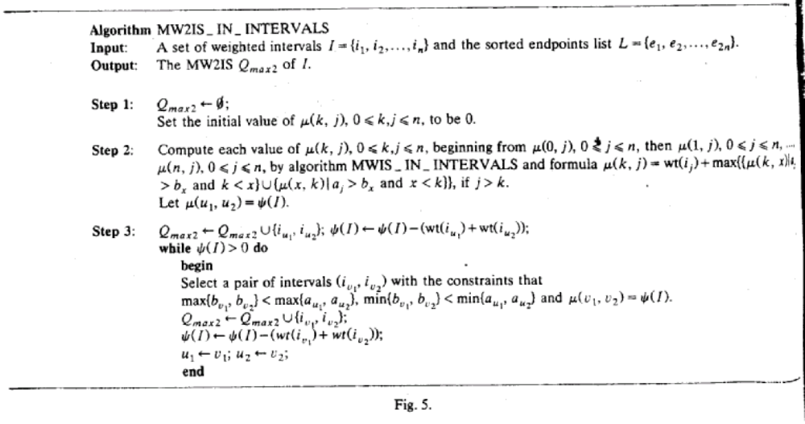

concept:
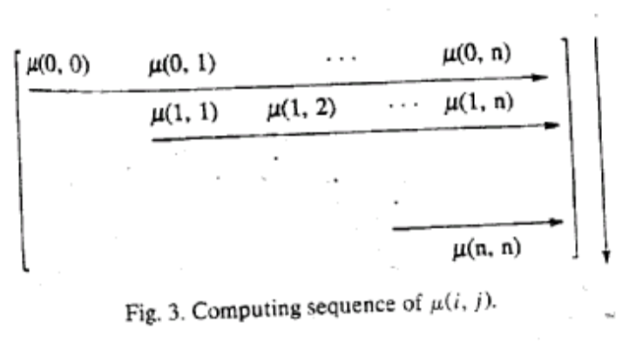
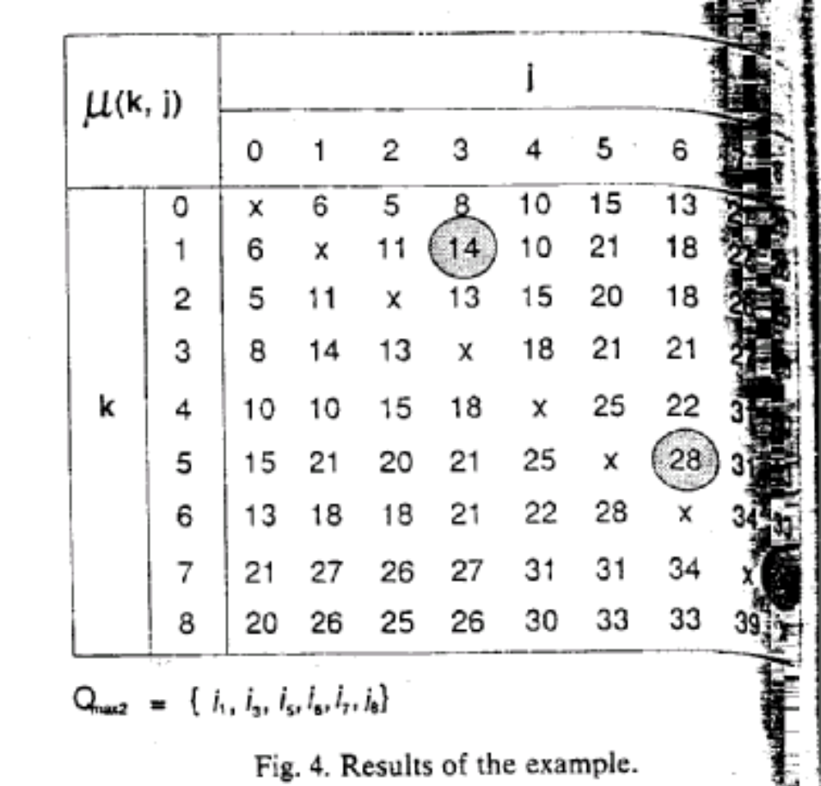
Created by: Sin-Huei Wu
Date: Dec. 2, 2001

